**Milestone 2 (Updated)**  
**NBB Group 15**  
**Abcedi Ilacas, Sarah Mathew and Wing Wong**

**ERD:**

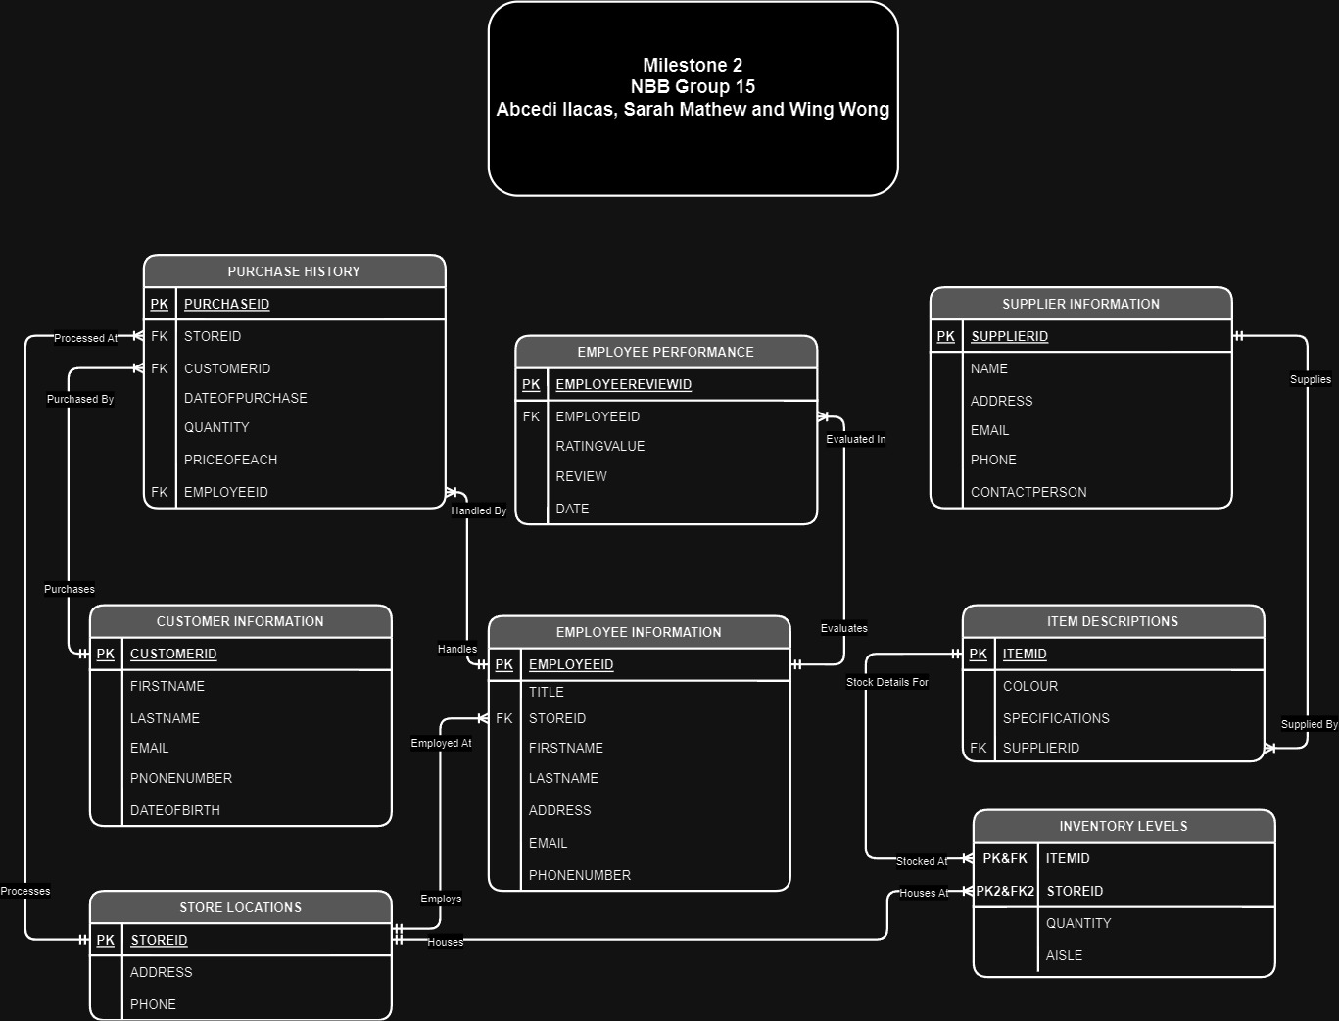

**Data Dictionary:**

TABLE: **Customer Information**

|  |  |  |  |  |  |  |  |  |  |
| --- | --- | --- | --- | --- | --- | --- | --- | --- | --- |
| **Column** | **Data Type** | **Size, Precision** | **Default** | **PK/FK** | **Required** | **Range** | **Sample Data** | **Notes** |  |
| customerID | Number | 5 |  | PK | Y | 1-9999 | 1234 | Autonumbered identity |  |
| firstName | String | 25 |  |  | Y |  | “Jane” |  |  |
| lastName | String | 25 |  |  | Y |  | “Doe” |  |  |
| DOB | Date |  |  |  |  |  | 1972/05/16 | Date of Birth (YYYY/MM/DD) |  |
| email | String | 80 |  |  | Y |  | “[Jane@abc.com](mailto:Jane@abc.com)” |  |  |
| phone | Number | 11 |  |  | Y | 2000000000-9999999999 | 9055551212 | Assuming North American phone number |  |

TABLE: **Employee Information**

|  |  |  |  |  |  |  |  |  |
| --- | --- | --- | --- | --- | --- | --- | --- | --- |
| **Column** | **Data Type** | **Size, Precision** | **Default** | **PK/FK** | **Required** | **Range** | **Sample Data** | **Notes** |
| employeeID | Number | 4 |  | PK | Y | 1-9999 | 2345 | Autonumbered identity |
| title | String | 25 |  |  | Y |  | “Sales Manager” | Job title |
| storeID | Number | 3 |  | FK |  |  | 22 | Working location |
| firstName | String | 25 |  |  | Y |  | “Bob” |  |
| lastName | String | 25 |  |  | Y |  | “Doe” |  |
| address | String | 25 |  |  | Y |  | “150 Street, North York, ON” | Personal address |
| email | String | 80 |  |  | Y |  | “[bobdoe@abc.com](mailto:bobdoe@abc.com)” | Work Email Address |
| phone | Number | 11 |  |  | Y | 2000000000-9999999999 | 9653332566 | Personal phone number. Assuming North American phone number |

TABLE: **Inventory Levels**

|  |  |  |  |  |  |  |  |  |
| --- | --- | --- | --- | --- | --- | --- | --- | --- |
| **Column** | **Data Type** | **Size, Precision** | **Default** | **PK/FK** | **Required** | **Range** | **Sample Data** | **Notes** |
| itemID | Number | 5 |  | PK&FK | Y | 1-9999 | 3456 | Autonumbered identity |
| quantity | Number | 4 |  |  | Y | 1-9999 | 965 | Quantity of the item left in store |
| aisle | Number | 2 |  |  | Y | 1-99 | 12 | Store aisle located |
| storeID | Number | 3 |  | PK&FK | Y | 1-999 | 22 | Store location |

TABLE: **Item Descriptions**

|  |  |  |  |  |  |  |  |  |
| --- | --- | --- | --- | --- | --- | --- | --- | --- |
| **Column** | **Data Type** | **Size, Precision** | **Default** | **PK/FK** | **Required** | **Range** | **Sample Data** | **Notes** |
| itemID | Number | 5 |  | PK | Y | 1-9999 | 3456 | Autonumbered identity |
| color | String | 25 |  |  |  |  | “Yellow” | Colour of item |
| spec | String | 50 |  |  |  |  | “USB TypeC Charger” | Item specification |
| supplierID | Number | 4 |  | FK | Y | 1-9999 | 23 | Supplier ID of the item |

TABLE: **Purchase History**

|  |  |  |  |  |  |  |  |  |
| --- | --- | --- | --- | --- | --- | --- | --- | --- |
| **Column** | **Data Type** | **Size, Precision** | **Default** | **PK/FK** | **Required** | **Range** | **Sample Data** | **Notes** |
| purchaseID | Number | 5 |  | PK | Y | 1-9999 | 5678 | Autonumbered identity |
| customerID | Number | 5 |  | FK | Y | 1-9999 | 1234 | Customers id number |
| storeID | Number | 3 |  | FK | Y | 1-999 | 22 | Store location |
| date | Date |  |  |  | Y |  | 2024/01/16 | Date of purchase (YYYY/MM/DD) |
| quantity | Number | 3 |  |  | Y | 1-999 | 12 | Quantity of purchased Item |
| priceOfEach | Number | 4 |  |  | Y | 1-9999 | 356.98 | Price of each purchased item |
| employeeID | Number | 5 |  | FK | Y | 1-9999 | 1972 | Employee handling this purchase |

TABLE: **Store Locations**

|  |  |  |  |  |  |  |  |  |
| --- | --- | --- | --- | --- | --- | --- | --- | --- |
| **Column** | **Data Type** | **Size, Precision** | **Default** | **PK/FK** | **Required** | **Range** | **Sample Data** | **Notes** |
| storeID | Number | 3 |  | PK | Y | 1-999 | 23 | Store ID |
| address | String | 80 |  |  |  |  | “150 Street, North York, ON” | The address of the store |
| phone | Number | 11 |  |  | Y | 2000000000-9999999999 | 9653332566 | Phone number of the store. Assuming North American phone number |

TABLE: **Employee Performance**

|  |  |  |  |  |  |  |  |  |
| --- | --- | --- | --- | --- | --- | --- | --- | --- |
| **Column** | **Data Type** | **Size, Precision** | **Default** | **PK/FK** | **Required** | **Range** | **Sample Data** | **Notes** |
| EmployeeReviewID | Number | 5 |  | PK | Y | 1 - 9999 | 1287 | Employee review ID |
| EmployeeID | Number | 5 |  | FK | Y | 1 - 9999 | 1972 | Employee ID |
| ratingValue | Number | 1 |  |  | Y | 1 - 9999 | 5 | Rating value 1 out of 5 |
| review | string | 50 |  |  | Y | 1 - 9999 | Extremely nice | Rating message |
| date | date |  |  |  | Y |  | 2024/05/18 | Review date |

TABLE: **Supplier Information**

|  |  |  |  |  |  |  |  |  |
| --- | --- | --- | --- | --- | --- | --- | --- | --- |
| **Column** | **Data Type** | **Size, Precision** | **Default** | **PK/FK** | **Required** | **Range** | **Sample Data** | **Notes** |
| supplierID | Number | 4 |  | PK | Y | 1-9999 | 333 | Autonumbered identity |
| name | String | 30 |  |  | Y |  | “XYZ Supplier” | Name of the Supplier |
| address | String | 80 |  |  | Y |  | “150 Street, North York, ON” | Address of the supplier |
| email | String | 50 |  |  | Y |  | “[enquiry@xyzsupplier.com](mailto:enquiry@xyzsupplier.com)” | Email address of the supplier |
| phone | Number | 11 |  |  | Y | 2000000000-9999999999 | 9055551212 | Assuming North American phone number |
| contactPerson | String | 20 |  |  | Y |  | “Peter Smith” | Full name of contact person |